1 run

training 1 epoch...

316.8399679660797 seconds used......

1 training finished! average train loss: 0.587127038630078

evaluating...

Confusion matrix, without normalization

[[ 381 54 55]

[ 610 2031 56]

[ 823 122 4465]]

Normalized confusion matrix

[[0.77755102 0.11020408 0.1122449 ]

[0.22617723 0.75305895 0.02076381]

[0.15212569 0.02255083 0.82532348]]

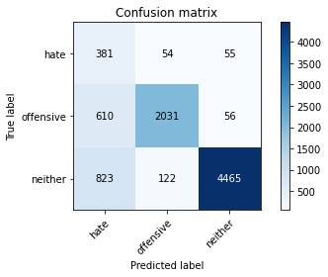

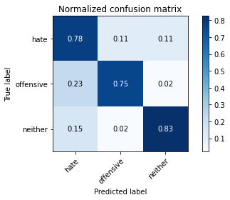

precision recall f1-score support

hate 0.21 0.78 0.33 490

offensive 0.92 0.75 0.83 2697

neither 0.98 0.83 0.89 5410

accuracy 0.80 8597

macro avg 0.70 0.79 0.68 8597

weighted avg 0.91 0.80 0.84 8597

average eval_loss: 0.526439121400201, accuracy: 0.799930208212167

training 2 epoch...

316.0396349430084 seconds used......

2 training finished! average train loss: 0.4419103582339311

evaluating...

Confusion matrix, without normalization

[[ 389 60 41]

[ 591 2068 38]

[1153 147 4110]]

Normalized confusion matrix

[[0.79387755 0.12244898 0.08367347]

[0.21913237 0.7667779 0.01408973]

[0.21312384 0.0271719 0.75970425]]

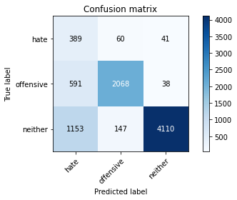

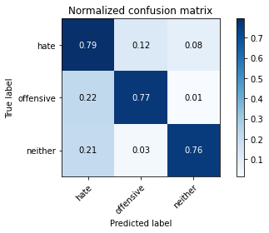

precision recall f1-score support

hate 0.18 0.79 0.30 490

offensive 0.91 0.77 0.83 2697

neither 0.98 0.76 0.86 5410

accuracy 0.76 8597

macro avg 0.69 0.77 0.66 8597

weighted avg 0.91 0.76 0.82 8597

average eval_loss: 0.6274484345039656, accuracy: 0.7638711178318018

training 3 epoch...

316.0823562145233 seconds used......

3 training finished! average train loss: 0.32780966287277435

evaluating...

Confusion matrix, without normalization

[[ 306 101 83]

[ 312 2290 95]

[ 533 168 4709]]

Normalized confusion matrix

[[0.6244898 0.20612245 0.16938776]

[0.11568409 0.84909158 0.03522432]

[0.09852126 0.0310536 0.87042514]]

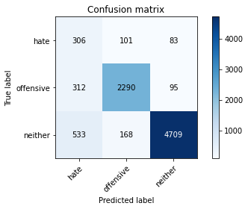

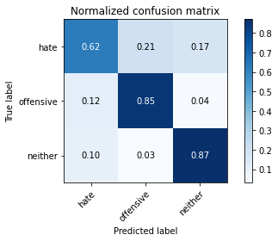

precision recall f1-score support

hate 0.27 0.62 0.37 490

offensive 0.89 0.85 0.87 2697

neither 0.96 0.87 0.91 5410

accuracy 0.85 8597

macro avg 0.71 0.78 0.72 8597

weighted avg 0.90 0.85 0.87 8597

average eval_loss: 0.45515299830152545, accuracy: 0.8497150168663488

training 4 epoch...

316.1565728187561 seconds used......

4 training finished! average train loss: 0.2237440260013918

evaluating...

Confusion matrix, without normalization

[[ 361 67 62]

[ 605 2022 70]

[ 790 173 4447]]

Normalized confusion matrix

[[0.73673469 0.13673469 0.12653061]

[0.22432332 0.74972191 0.02595476]

[0.14602588 0.03197782 0.8219963 ]]

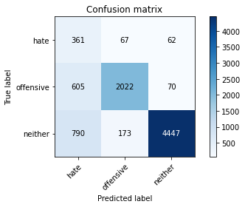

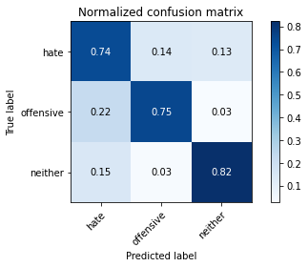

precision recall f1-score support

hate 0.21 0.74 0.32 490

offensive 0.89 0.75 0.82 2697

neither 0.97 0.82 0.89 5410

accuracy 0.79 8597

macro avg 0.69 0.77 0.68 8597

weighted avg 0.90 0.79 0.83 8597

average eval_loss: 0.6953476587830242, accuracy: 0.7944631848319181

training 5 epoch...

316.1230089664459 seconds used......

5 training finished! average train loss: 0.14381403439344737

evaluating...

Confusion matrix, without normalization

[[ 349 80 61]

[ 617 2033 47]

[1106 166 4138]]

Normalized confusion matrix

[[0.7122449 0.16326531 0.1244898 ]

[0.22877271 0.75380052 0.01742677]

[0.20443623 0.03068392 0.76487985]]

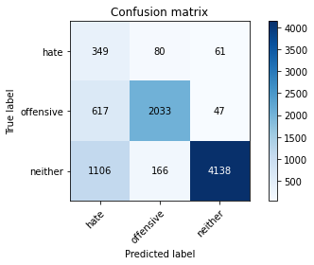

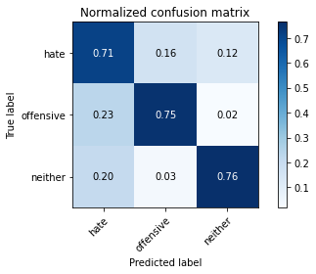

precision recall f1-score support

hate 0.17 0.71 0.27 490

offensive 0.89 0.75 0.82 2697

neither 0.97 0.76 0.86 5410

accuracy 0.76 8597

macro avg 0.68 0.74 0.65 8597

weighted avg 0.90 0.76 0.81 8597

average eval_loss: 0.9394444091375485, accuracy: 0.7584040944515529

model of 2 epoch

Confusion matrix, without normalization

[[ 418 73 41]

[ 563 2117 30]

[1119 162 4074]]

Normalized confusion matrix

[[0.78571429 0.13721805 0.07706767]

[0.20774908 0.78118081 0.01107011]

[0.20896359 0.0302521 0.76078431]]

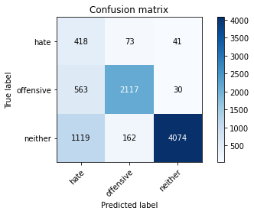

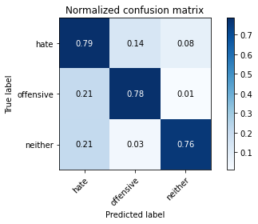

precision recall f1-score support

hate 0.20 0.79 0.32 532

offensive 0.90 0.78 0.84 2710

neither 0.98 0.76 0.86 5355

accuracy 0.77 8597

macro avg 0.69 0.78 0.67 8597

weighted avg 0.91 0.77 0.82 8597

average eval_loss: 0.6285168261722077, accuracy: 0.7687565429801093

[18]:

0.7687565429801093

2 run

training 1 epoch...

316.9622483253479 seconds used......

1 training finished! average train loss: 0.5899990882120423

evaluating...

Confusion matrix, without normalization

[[ 310 95 85]

[ 352 2263 82]

[ 419 144 4847]]

Normalized confusion matrix

[[0.63265306 0.19387755 0.17346939]

[0.13051539 0.83908046 0.03040415]

[0.07744917 0.02661738 0.89593346]]

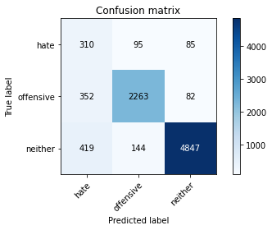

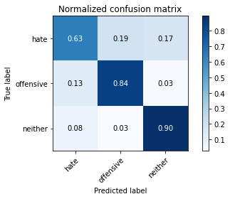

precision recall f1-score support

hate 0.29 0.63 0.39 490

offensive 0.90 0.84 0.87 2697

neither 0.97 0.90 0.93 5410

accuracy 0.86 8597

macro avg 0.72 0.79 0.73 8597

weighted avg 0.91 0.86 0.88 8597

average eval_loss: 0.4157397581740867, accuracy: 0.8630917762010003

training 2 epoch...

316.5463547706604 seconds used......

2 training finished! average train loss: 0.43476848411247937

evaluating...

Confusion matrix, without normalization

[[ 271 127 92]

[ 200 2401 96]

[ 384 201 4825]]

Normalized confusion matrix

[[0.55306122 0.25918367 0.1877551 ]

[0.07415647 0.89024842 0.03559511]

[0.07097967 0.03715342 0.89186691]]

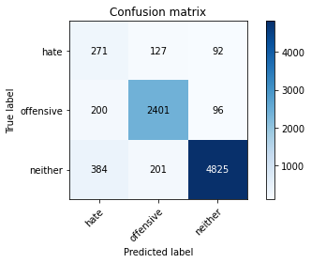

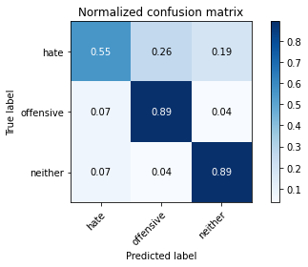

precision recall f1-score support

hate 0.32 0.55 0.40 490

offensive 0.88 0.89 0.88 2697

neither 0.96 0.89 0.93 5410

accuracy 0.87 8597

macro avg 0.72 0.78 0.74 8597

weighted avg 0.90 0.87 0.88 8597

average eval_loss: 0.37799240260623224, accuracy: 0.8720483889728975

training 3 epoch...

316.4900572299957 seconds used......

3 training finished! average train loss: 0.31862661925874447

evaluating...

Confusion matrix, without normalization

[[ 323 95 72]

[ 410 2218 69]

[ 673 169 4568]]

Normalized confusion matrix

[[0.65918367 0.19387755 0.14693878]

[0.15202076 0.82239525 0.02558398]

[0.12439926 0.03123845 0.84436229]]

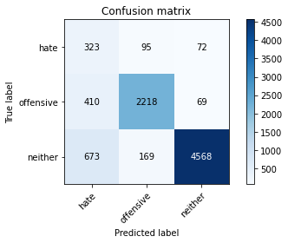

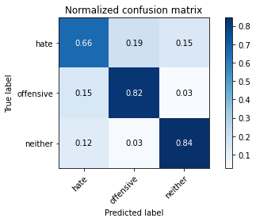

precision recall f1-score support

hate 0.23 0.66 0.34 490

offensive 0.89 0.82 0.86 2697

neither 0.97 0.84 0.90 5410

accuracy 0.83 8597

macro avg 0.70 0.78 0.70 8597

weighted avg 0.90 0.83 0.86 8597

average eval_loss: 0.5031089184935703, accuracy: 0.8269163661742468

training 4 epoch...

316.5751655101776 seconds used......

4 training finished! average train loss: 0.20546212765652486

evaluating...

Confusion matrix, without normalization

[[ 344 73 73]

[ 541 2069 87]

[ 713 130 4567]]

Normalized confusion matrix

[[0.70204082 0.14897959 0.14897959]

[0.20059325 0.76714868 0.03225806]

[0.13179298 0.02402957 0.84417745]]

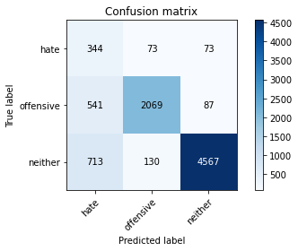

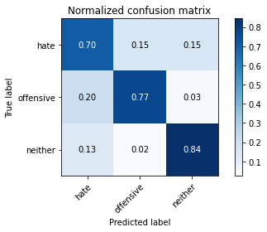

precision recall f1-score support

hate 0.22 0.70 0.33 490

offensive 0.91 0.77 0.83 2697

neither 0.97 0.84 0.90 5410

accuracy 0.81 8597

macro avg 0.70 0.77 0.69 8597

weighted avg 0.91 0.81 0.85 8597

average eval_loss: 0.6795914680805317, accuracy: 0.8119111317901594

training 5 epoch...

316.65826058387756 seconds used......

5 training finished! average train loss: 0.13672033507798523

evaluating...

Confusion matrix, without normalization

[[ 350 68 72]

[ 614 2009 74]

[ 844 140 4426]]

Normalized confusion matrix

[[0.71428571 0.13877551 0.14693878]

[0.22766036 0.74490174 0.02743789]

[0.15600739 0.025878 0.8181146 ]]

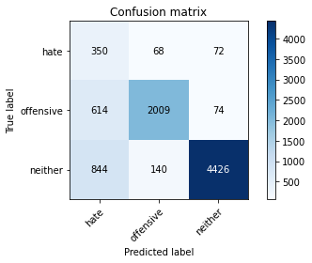

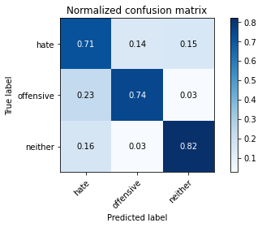

precision recall f1-score support

hate 0.19 0.71 0.30 490

offensive 0.91 0.74 0.82 2697

neither 0.97 0.82 0.89 5410

accuracy 0.79 8597

macro avg 0.69 0.76 0.67 8597

weighted avg 0.90 0.79 0.83 8597

average eval_loss: 0.830922496548399, accuracy: 0.7892288007444458

Confusion matrix, without normalization

[[ 376 83 73]

[ 574 2071 65]

[ 837 156 4362]]

Normalized confusion matrix

[[0.70676692 0.15601504 0.13721805]

[0.21180812 0.76420664 0.02398524]

[0.15630252 0.02913165 0.81456583]]

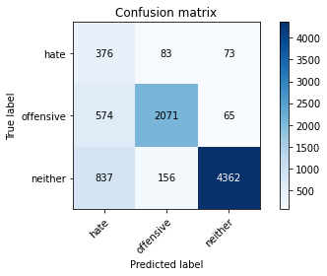

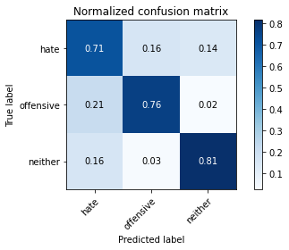

precision recall f1-score support

hate 0.21 0.71 0.32 532

offensive 0.90 0.76 0.83 2710

neither 0.97 0.81 0.89 5355

accuracy 0.79 8597

macro avg 0.69 0.76 0.68 8597

weighted avg 0.90 0.79 0.83 8597

average eval_loss: 0.8276620765281625, accuracy: 0.7920204722577643

[19]:

0.7920204722577643

3 run

training 1 epoch...

316.64287066459656 seconds used......

1 training finished! average train loss: 0.5793287078472408

evaluating...

Confusion matrix, without normalization

[[ 326 81 83]

[ 425 2193 79]

[ 518 124 4768]]

Normalized confusion matrix

[[0.66530612 0.16530612 0.16938776]

[0.1575825 0.8131257 0.02929181]

[0.09574861 0.02292052 0.88133087]]

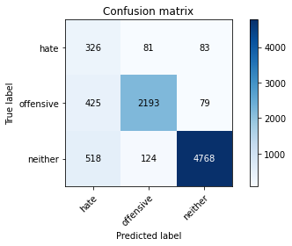

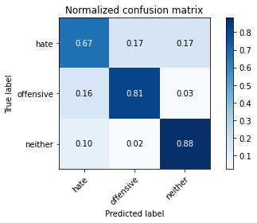

precision recall f1-score support

hate 0.26 0.67 0.37 490

offensive 0.91 0.81 0.86 2697

neither 0.97 0.88 0.92 5410

accuracy 0.85 8597

macro avg 0.71 0.79 0.72 8597

weighted avg 0.91 0.85 0.87 8597

average eval_loss: 0.429608625346838, accuracy: 0.8476212632313598

training 2 epoch...

316.67154145240784 seconds used......

2 training finished! average train loss: 0.4385020550139047

evaluating...

Confusion matrix, without normalization

[[ 297 111 82]

[ 264 2351 82]

[ 447 189 4774]]

Normalized confusion matrix

[[0.60612245 0.22653061 0.16734694]

[0.09788654 0.87170931 0.03040415]

[0.08262477 0.0349353 0.88243993]]

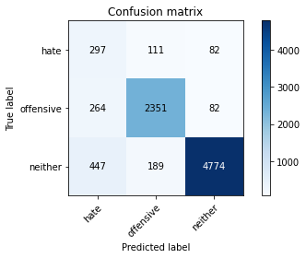

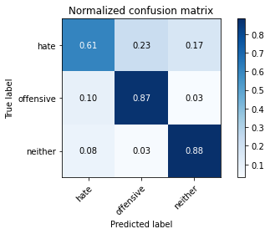

precision recall f1-score support

hate 0.29 0.61 0.40 490

offensive 0.89 0.87 0.88 2697

neither 0.97 0.88 0.92 5410

accuracy 0.86 8597

macro avg 0.72 0.79 0.73 8597

weighted avg 0.90 0.86 0.88 8597

average eval_loss: 0.40092189823125685, accuracy: 0.8633244154937769

training 3 epoch...

316.6911070346832 seconds used......

3 training finished! average train loss: 0.32084618379815005

evaluating...

Confusion matrix, without normalization

[[ 373 62 55]

[ 572 2068 57]

[ 890 205 4315]]

Normalized confusion matrix

[[0.76122449 0.12653061 0.1122449 ]

[0.2120875 0.7667779 0.02113459]

[0.16451017 0.03789279 0.79759704]]

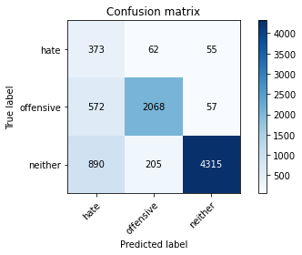

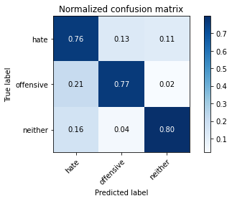

precision recall f1-score support

hate 0.20 0.76 0.32 490

offensive 0.89 0.77 0.82 2697

neither 0.97 0.80 0.88 5410

accuracy 0.79 8597

macro avg 0.69 0.78 0.67 8597

weighted avg 0.90 0.79 0.83 8597

average eval_loss: 0.6563108975111052, accuracy: 0.7858555309991858

training 4 epoch...

316.5832269191742 seconds used......

4 training finished! average train loss: 0.214497479128752

evaluating...

Confusion matrix, without normalization

[[ 310 106 74]

[ 342 2287 68]

[ 606 232 4572]]

Normalized confusion matrix

[[0.63265306 0.21632653 0.15102041]

[0.12680756 0.84797924 0.0252132 ]

[0.11201479 0.04288355 0.84510166]]

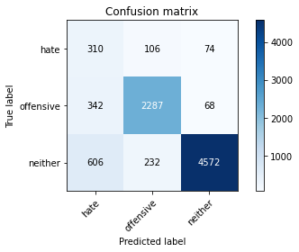

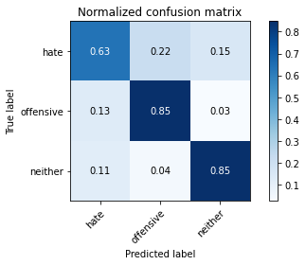

precision recall f1-score support

hate 0.25 0.63 0.35 490

offensive 0.87 0.85 0.86 2697

neither 0.97 0.85 0.90 5410

accuracy 0.83 8597

macro avg 0.70 0.78 0.71 8597

weighted avg 0.90 0.83 0.86 8597

average eval_loss: 0.5850816874699883, accuracy: 0.8338955449575434

training 5 epoch...

316.5912215709686 seconds used......

5 training finished! average train loss: 0.14407640770140634

evaluating...

Confusion matrix, without normalization

[[ 316 85 89]

[ 510 2091 96]

[ 584 145 4681]]

Normalized confusion matrix

[[0.64489796 0.17346939 0.18163265]

[0.189099 0.7753059 0.03559511]

[0.10794824 0.02680222 0.86524954]]

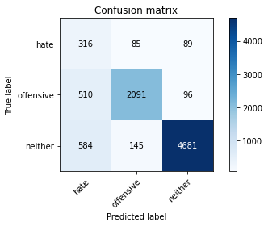

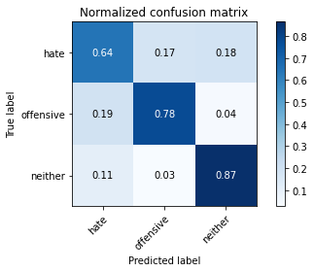

precision recall f1-score support

hate 0.22 0.64 0.33 490

offensive 0.90 0.78 0.83 2697

neither 0.96 0.87 0.91 5410

accuracy 0.82 8597

macro avg 0.70 0.76 0.69 8597

weighted avg 0.90 0.82 0.85 8597

average eval_loss: 0.6669924619477675, accuracy: 0.8244736536000931

Confusion matrix, without normalization

[[ 393 78 61]

[ 562 2103 45]

[ 895 200 4260]]

Normalized confusion matrix

[[0.7387218 0.14661654 0.11466165]

[0.20738007 0.77601476 0.01660517]

[0.16713352 0.03734827 0.79551821]]

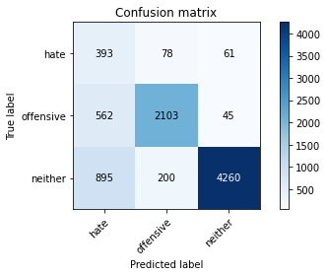

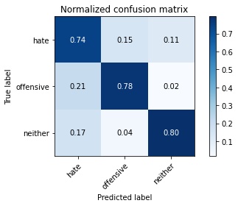

precision recall f1-score support

hate 0.21 0.74 0.33 532

offensive 0.88 0.78 0.83 2710

neither 0.98 0.80 0.88 5355

accuracy 0.79 8597

macro avg 0.69 0.77 0.68 8597

weighted avg 0.90 0.79 0.83 8597

average eval_loss: 0.6604486347111158, accuracy: 0.7858555309991858

[21]:

0.7858555309991858